**Course Project   
DeVry University  
College of Engineering and Information Sciences**

**Course Number: CEIS312**

Module 4 Report

## Regression Modeling Feature Engineering

**Take a screenshot of the scatter plot showing Relative Compactness versus Heating Load. Look closely at the various orientation plots. Explain why orientation is not a significant feature based on the plots.**

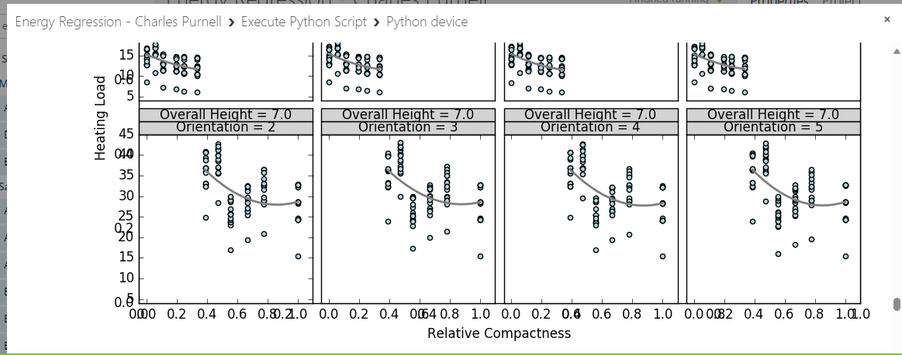

**The plots are uniform or random, meaning that the orientations are evenly or randomly distributed across the coordinate system. This indicates that there is no preferred or dominant orientation in the dataset.**

**Take a screenshot of the boxplot of heating load. Examine this chart and note how different the distribution of Heating Load is for the two values of Overall Height. Be sure to list the two values of Overall Height we are researching.**

## Create and Train a Model

**Take a screenshot of the result of the Linear Regression analysis.**

